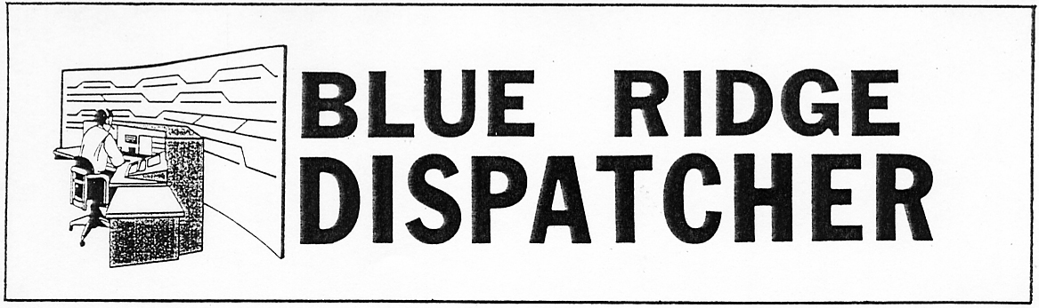
Vol. 19 August 2011 No. 8

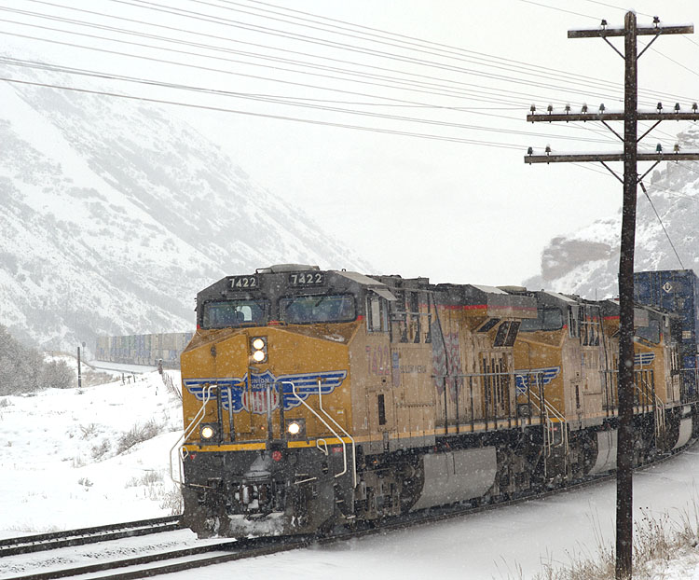

August 2011 BRC program will be Winter on The Wasatch 2010 so y'all bring an overcoat!!

Between the three monumental snow storms in Virginia in February 2010, Bob Kaplan and I managed to fly out of Dulles to Salt Lake City for a ten day swing through Utah and Nevada. The August program show will focus on Soldier Summit, an afternoon photographing Salt Lake City's restored street railway, Union Pacific's main line thru Echo Canyon and some short lines we encountered along the way. Pictured here is an eastbound UP stack train snaking its way up Echo Canyon on Day 8 of our trip. All too soon, the adventure ended as our flight back home was not cancelled. When we got back to my beloved Commonwealth, there was more snow on the ground here than there was at Soldier Summit. Go figure!! See you at the August meeting. Dale Diacont

Wednesday, August 10, 2011. 6:00 p.m.
Charley’s Restaurant. 707 Graves Mill Rd. Lynchburg, VA

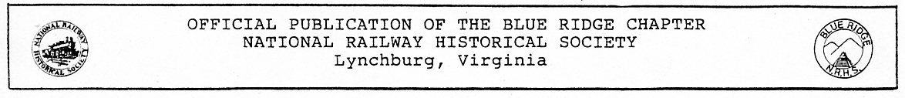
Blue Ridge Chapter, National Railway Historical Society
Minutes of Meeting - July 13, 2011

President Rick Johnson called the meeting to order at Charley’s Restaurant shortly after 7:30 p.m. There were 22 members and 2 guests present. Rick welcomed Reg Akers as an official member, and Gary Quale, returning after knee surgery. The minutes of the June meeting were approved as distributed. Secretary Tom Ledford was on vacation. Lloyd Lipscomb was asked to take the minutes. John Tanner gave the treasurer’s report.
Under new business Norris Deyerle, BRC Chairman for the Virginia Rail Heritage Partners, reported that Rick Tabb of the C&O Historical Society invited the Chapter to a tour of the C&O Heritage Center in Clifton Forge on July 24. The 614 locomotive will be on display. Members and friends were invited to sign up and form car pools. Norris also announced that the Chapter picnic will be held on Sept. 18 and the Christmas banquet on Dec. 3, both in Altavista.
Skip Hansberry moved that the Chapter donate $100 to the Virginia Museum of Transportation for the re-painting of the 1976 bi-centennial locomotive. (Skip said that he planned to give $100 for that purpose and hoped the Chapter would match his gift.) The motion was seconded and passed.
Barry Moorefield discussed plans for Rail Day on Saturday, August 13. Members and friends were asked to sign up for work with the white elephant table, concessions, and setting up on the day before. Ed Fielding will present a show on the Virginia Blue Ridge Railway between 12 and 1 o’clock on Rail Day.
In conclusion Rick Johnson thanked Editor Garland Harper for the July issue of the “Blue Ridge Dispatcher.” Many members found it particularly interesting. At the fun meeting on July 27, David Helmer of the Roanoke Chapter will show pictures of Viet Nam railways. Dale Diacont will present the program at the regular meeting on August 12.
Charlie Long won the 50-50 drawing. Four other members won caps with rail themes, donated by Gary Quale.
Fred Mayer presented a video he compiled on “Railroads in Montana.” Railroads featured were the Montana Rail Link, the Milwaukee Road, and the Burlington Northern (now BNSF).

Lloyd Lipscomb, Acting Secretary

The Blue Ridge Chapter, National Railway Historical Society presents:
LYNCHBURG RAIL DAY 2011 - Saturday, August 13, 2011
9 a.m. – 4 p.m.

* * * BOONSBORO RURITAN CLUB, LYNCHBURG, VA * * *
Admission: $6/person, Family admission: $10. Children 12/under free w/paying adult
TRAIN EXHIBITS, SLIDE SHOW, AND OPERATING MODEL LAYOUTS ON DISPLAY
DOOR PRIZES AND FRESHLY PREPARED FOOD/BEVERAGES AVAILABLE

* * * * * * * *BARGAIN MART * * * * * * * *
Model train items and Railroad Memorabilia with Vendors from around the Region
Sales tables available to the general public, advance registration/payment required.
8 foot tables: $33.00 each, 6 foot tables: $25.00 each, Table Size Subject To Availability

* * * * * “WHITE ELEPHANT” TABLE * * * * *
Available to train show attendees, the Blue Ridge Chapter N.R.H.S. will sell your model trains and Railroad Memorabilia for a 20% commission, MAKE MONEY WHILE YOU BROWSE THE SHOW.

* * RAILROAD MODEL/PHOTOGRAPHY EXPOSITION/CONTEST * *
Contests open to public, Information: contact Fred Mayer (434-384-2773) barbalin@comcast.net
For more train show information and to rent Vendor Tables contact:
Barry Moorefield (434-821-2174-before 9 p.m.), bmopar@verizon.net
John Tanner (434-525-1318), flytrains@verizon.net
Norris Deyerle, (434-237-4912), railcow@msn.com
Blue Ridge Chapter, N.R.H.S., P.O. Box 11731, Lynchburg, Va. 24506-1731
Website: www.blueridgenrhs.org

Blue Ridge Chapter, NRHS, 2011 Calendar of Events
53RD Anniversary of the Blue Ridge Chapter
A Virginia’s Rail Heritage Region Partner
Compiled By Norris Deyerle,
Blue Ridge Chapter, NRHS Chairman of Virginia’s Rail Heritage Region Partners
Newly added events since last month printed in “Bold Italics”.

Notice: The East Broad Top Railroad National Historical Landmark has many events planned for the rest of 2011. Info: www.ebtrr.com. Their neighbor next door, The Rockhill Trolley Museum also has events planned. Info: www.rockhilltrolley.org. The NRHS is the lead member of a new group of railway heritage groups and preservationists that list their upcoming events on their new website, RHICalendar@nrhs.com. The EBRR and the Rock Hill Trolley Museum both have their events listed along with dozens of other groups. I emailed our LRD 2011 Media Release to the Railway Heritage Initiative Planning Calendar. I urge our friends with the other railway historical groups and museums to take advantage of this new NRHS service. There is no cost to subscribe to this service. This is a website that will help us all get the word out about our events!
Steam Train Events in the United States and Canada! www.diary.svsfilm.com

August 2011:
08-03-07-11: {Wednesday – Sunday} C&OHS Annual Conference, Cincinnati, Ohio, www.cohs.org
08-06-11: {Saturday} VTC Charlottesville Summer Train Meet, Holiday Inn Monticello, Exit 120 off I-64 at 5th Street, 1200 5th Street SW, Charlottesville, Va. 22902. 9:00 am till 3:00 pm. $6.00 at door {Members $5.00} Info: Contact Stuart Gordon, {804} 798-3739 5:00 pm till 9:00 pm. or www.vatraincollectors.com
08-06–07-11: {Saturday and Sunday} Greenberg’s Train and Toy Show, Maryland State Fairgrounds, 2200 York Road, Timonium, Md. 21093 Info: www.greenbergshows.com/schedule {Courtesy of the Lancaster Dispatcher}
08-10-11: {Wednesday} BRC, NRHS Monthly Meeting, Dale Diacont will present a digital show on “Winter On The Wasatch 2010”. Dale assures us it’s going to be really cold in the room while his show is going on! Better bring a coat! Ha!
08-13-11: {Saturday} Lynchburg Rail Day 2011 by the BRC, NRHS, 9:00 am – 4:00 pm, Boonsboro Ruritan Club, 1065 Coffee Road, Lynchburg, Va. 24503, Model Train Show and Vendor Information is now available on our website, www.blueridgenrhs.org. We are now accepting table registrations on a first come first served basis. Table space is limited and usually sells out prior to the show. This is the only model train show in our area. If you have questions please contact Barry Moorefield, {434} 821-2174 before 9:00 p.m., bmopar@verizon.net, Norris Deyerle, {434} 237-4912 railcow@msn.com, John Tanner {434} 525-1318 flytrains@verizon.net Model & Photography Contest Chairman: Fred Mayer {434} 384-2773 barbalin@comcast.net
08-18-11: {Thursday} Roanoke Chapter, NRHS Membership Meeting, Guests Welcome, OWLM, 7:30 pm, Roanoke, Va. Info: www.roanokenrhs.org
September 2011:
09-10-11: {Saturday} Trainfest Summer 2011 Model Train Sale, Hagerstown Model Railroad Museum, Washington County Ag Center, 7313 Sharpsburg Pike, 6.5 miles South of I-70 on Route 65. 9:00 am till 2:00 pm. Admission: $4.00 adults, under 12 free. {Courtesy of the Shenandoah Valley Express}
09-14-11: {Wednesday} BRC, NRHS Monthly Meeting, Vintage N&W Railway and Virginian Railway Slide Show, Norris Deyerle
09-15-11: {Thursday} Roanoke Chapter, NRHS Membership Meeting, Guests Welcome, OWLM, 7:30 pm, Roanoke, Va. Info: www.roanokenrhs.org
09-18-11: {Sunday} BRC, NRHS Annual Chapter Picnic, English Park, next to the former Virginian Railway mainline, Altavista, Va. Noon till 4:00 pm. We usually eat around 1:00 pm and have finished eating by 2:00 – 2:30 pm. The BRC will supply the fried chicken, drinks and ice. Attendees are asked to bring a covered dish or dessert to share with the others. Guests are welcome. If you’re coming, please contact Norris Deyerle at least a week ahead of time, by 9-11-11, so he can order the chicken. Email Norris at railcow@msn.com
09-23-25 & 30 – October 2-11: “Day Out With Thomas at the NCTM” North Carolina Transportation Museum, Spencer, NC Info: 704-636-2889, www.nctrans.org
09-28-11: {Wednesday} BRC, NRHS “Fun Meeting”, Wayland Moore will feature a digital show on more recent trains from his travels to CA, Australia and KY! That will probably be in the order he presents them knowing Wayland! From one side of the world then back to the other! Ha! I can’t wait.
October 2011
10-12-11: {Wednesday} BRC, NRHS Monthly Meeting, Kurt Reisweber
10-13-15-11: {Thursday-Saturday} Train Collectors Association, Fall York Train Meet, York, Pa. Info: www.tca.org
10-20-11: {Thursday} Roanoke Chapter, NRHS Membership Meeting, Guests Welcome, OWLM, 7:30 pm, Roanoke, Va. Info: www.roanokenrhs.org
10-29-11: {Saturday} North Carolina Transportation Museum excursion to Roanoke, Va. Two options when in Roanoke are to visit the O. Winston Link Museum in the former N&W Passenger Station or the Virginia Museum Of Transportation. Complete information and to order tickets call: 704-636-2889, ext. 237 or visit www.nctrans.org {Courtesy of the “Piedmont Flyer”}
November 2011:
11-05-06-11: {Saturday & Sunday} Two Fall Foliage Amtrak Excursions from Roanoke, Va. Roanoke Chapter, NRHS, Info: www.roanokenrhs.org
11-06-11: {Sunday} 34th Annual Railroadiana & Transportation Artifacts Show and Sale, Montgomery County Fairgrounds, Gaithersburg, Md. Info: www.gserr.com
11-09-11: {Wednesday} BRC, NRHS Monthly Meeting, Rick-2 Johnson
11-17-11: {Thursday} Roanoke Chapter, NRHS Membership Meeting, Guests Welcome, OWLM, 7:30 pm, Roanoke, Va. Info: www.roanokenrhs.org
11-23-11: No BRC, NRHS “Fun Meeting” due to the Thanksgiving Holiday.
December 2011:
12-03-11: {Saturday} BRC, NRHS Annual Christmas Banquet, Former Southern Railway Depot, Altavista, Va. Reservations Required.
12-14-11: {Wednesday} BRC, NRHS Monthly Meeting, Charlie Long - Video
12-17-11: {Saturday} BRC, NRHS Annual Kemper Street Station Christmas Gathering. Kemper Street Station, Lynchburg, Va.
Upcoming Railroad Related Events Information: Visit: www.varailheritage.org, www.vmt.org, www.linkmuseum.org, www.roanokenrhs.org, www.nwhs.org, www.cohs.org, www.vatraincollectors.com, www.klnl.org, www.nhvry.org, www.norfolksouthernhs.org, www.RailServe.com, www.trains.com, www.TrainFinder.com, www.gserr.com or RHICalendar@nrhs.com.
Steam Train Events in the United States and Canada: www.diary.svsfilm.com
Railroad Historical Information And Related Photos: www.hawkinsrails.net
Danville & Western Ry. Website: Railway operated in Southwestern Virginia between Danville and Stuart. http://southern-railway.railfan.net/dw/
Additional links to other NRHS Chapters, Railroad Historical Societies and Museums available at www.blueridgenrhs.org
Virginia Museum Of Transportation Rail Cam: http://www.nwhs.org/cam/vmt
Roanoke, Va. Rail Cam: http://128.173.197.94:443/RRCmov
Lynchburg Rail Day 2011 {Saturday} August 13, 2011
Lynchburg Rail Day 2012 {Saturday} August 11, 2012

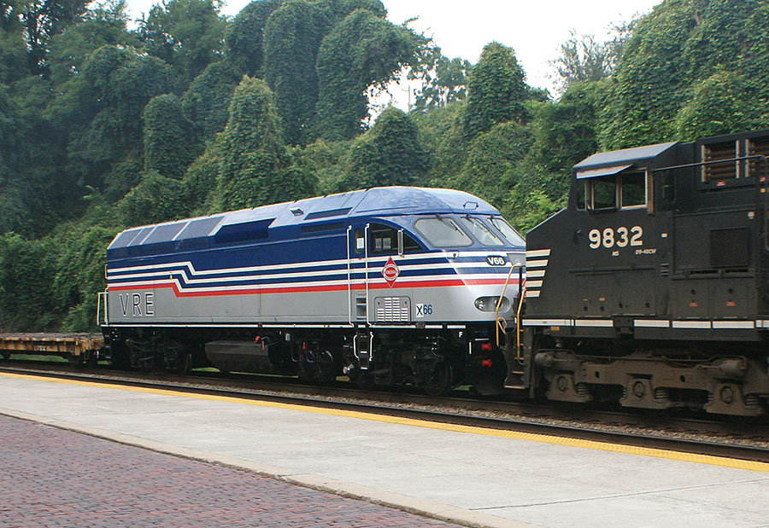
SIGHTINGS
Aug. 2 and 3 – Virginia Railway Express engine X66 spotted in Kinney Yard and the next day in tow en route to Manassas on NS train P98. (Charlie Long, G. Harper)

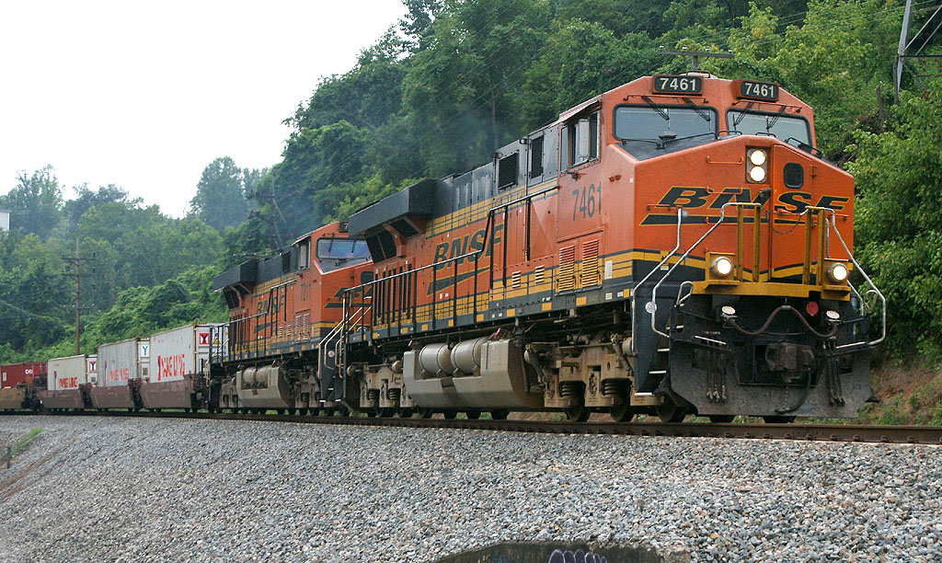
Aug. 3 – Two BNSF units, 7461 and 7211, spotted eastbound on rerouted CSX container train Q130 passing through Sandy Hook Yard in downtown Lynchburg. (Galen Wright)
Aug. 5 – Same pair of BNSF units seen on westbound container
train Q13504 at Reusens Dam. It is quite rare to see foreign power
on CSX in Lynchburg. (G. Harper)

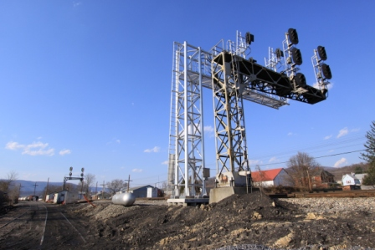
Signal Scenes – Rick Johnson–II offers these scenes of signals which can no longer be duplicated. The four signals along the former C&O in the Clifton Forge area have been replaced since these were taken.
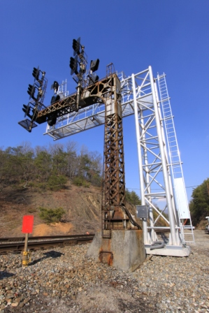
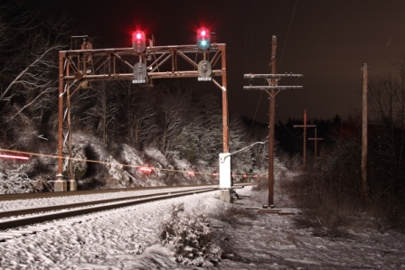
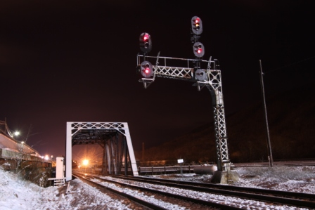
Eastbound cantilever at Jackson River. 12/5/10 Westbound cantilever with replacement at Chestnut St. 3/12/11

Eastbound coal train lights up the signal bridge at Calleghan.
Signal caught changing. 12/5/10

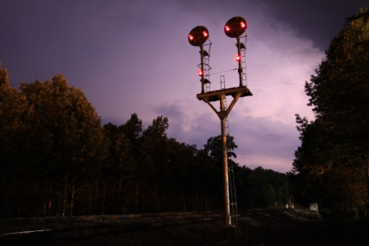

Westbound cantilever with replacement at Chestnut St.
3/12/11

NEW MEMBER!
Reggie Akers, a long time friend of the Blue Ridge Chapter, NRHS, has become a member! Be sure to welcome him the next time you see him.

And as an extra bonus, Rick offers us this image of the N&W
color position signal at Bowler with thunderstorm in progress.
Signal still stands, but not for long as the switch here will be
replaced with a hand-throw switch meaning the signal will no
longer be necessary. This style of signal is very much
an endangered species all over former N&W territory! 6/16/11

CHAPTER OFFICERS AND STAFF

President Rick Johnson, 104 Mowry Ln. Lynchburg, VA 24502
434-660-1113 notch8@aol.com
Vice President Charlie Long, 106 Pacos St., Lynchburg, VA 24502
434-239-3521 cwlongjr@mindspring.com
Secretary Tom Ledford, 2186 Woodcrest Dr., Lynchburg, VA 24503
434-384-2013 tomledford@hotmail.com
Treasurer John Tanner, 209 Pocahontas Dr., Forest, VA 24551-1235
434-525-1318 flytrains@ verizon.net
National Director Earl Guthrow 1909 Quarry Rd. Lynchburg, VA 24503
434-384-2583 meguthrow@verizon.net
Editor Garland R. Harper, 3920 Harbor St. Lynchburg, VA 24503 434-384-7210 GRHarper@aol.com
Historian Rick Johnson, 104 Mowry Ln. Lynchburg, VA 24502
434-660-1113 notch8@aol.com
Webmaster John Siegle 1225 Krise Cir. Lynchburg, VA 24503
    - jas65@comcast.net
BRC Chairman. VA Rail E. Norris Deyerle, Jr. 744 Chinook Pl., Lynchburg, VA 24502
Heritage Region Partners 434-237-4912 railcow@msn.com

The BLUE RIDGE DISPATCHER is published by the Blue Ridge Chapter, National Railway Historical Society. Opinions expressed are those of the editor and contributors and do not necessarily reflect the views of the Blue Ridge Chapter or the National Railway Historical Society unless otherwise stated.

Blue Ridge Chapter, NRHS
P. O. Box 11731
Lynchburg, VA 24506-1731
www.blueridgenrhs.org

IT’S HERE!!!
LYNCHBURG RAIL DAY 2011. Saturday, August 13, 2011.

