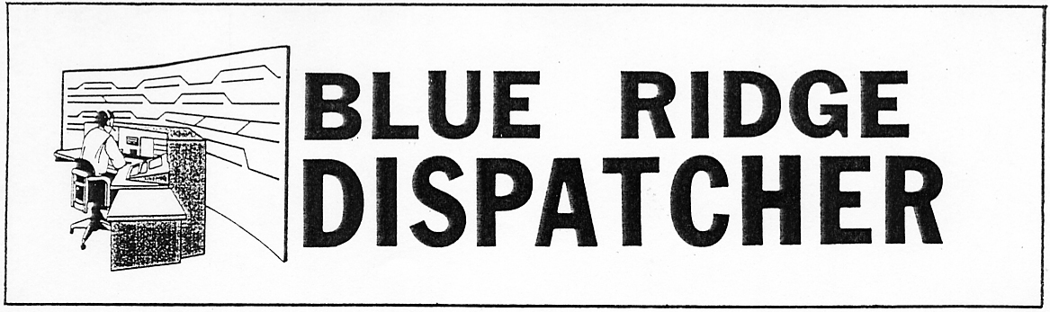
Vol. 20 January 2012 No. 1
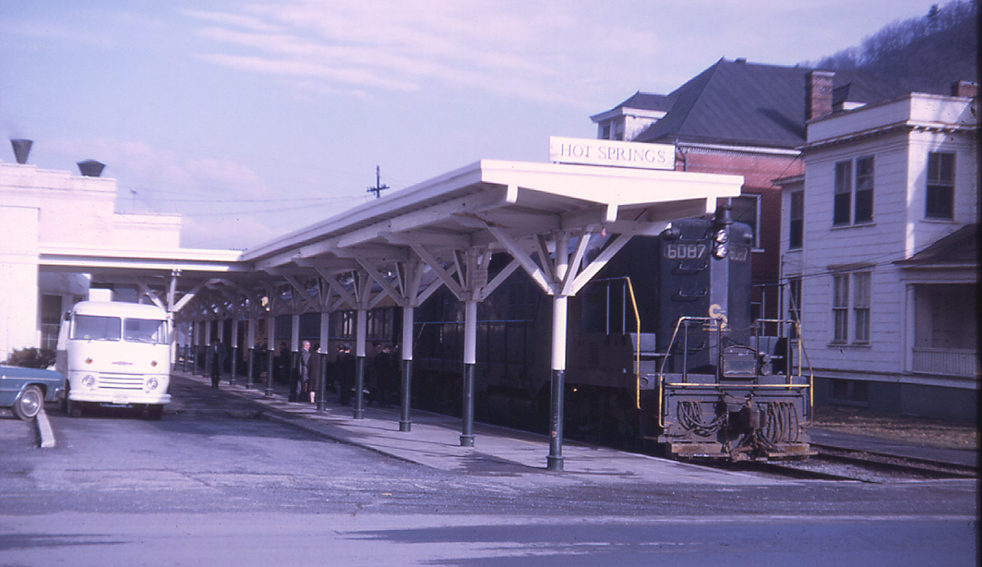

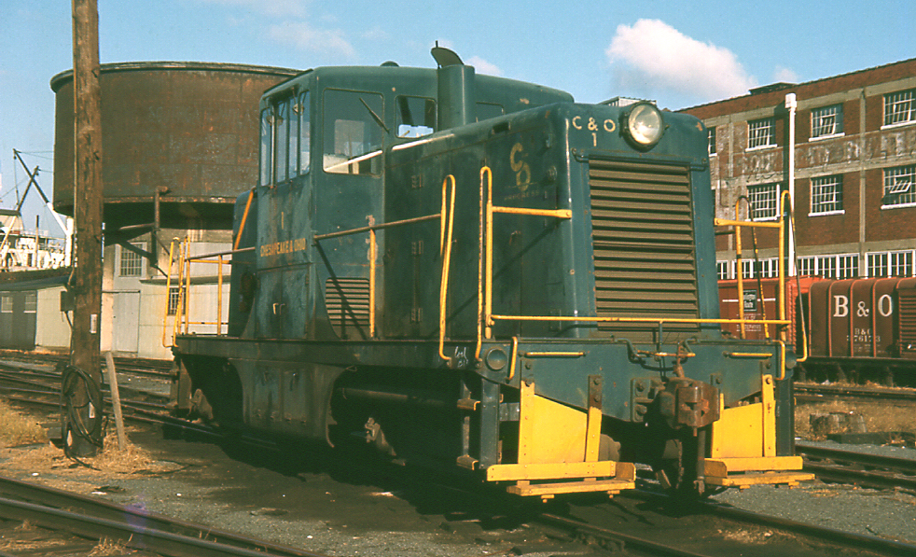

Ed Fielding brings us the first show of 2012. He's entitled it Fifty Years of Railfanning. He began taking train pictures, especially slides, in the winter of 1962 after receiving a small 35mm camera for Christmas 1961. Thus began an enjoyable hobby he has indulged in ever since. Many surprises will show up during his show, since, needless to say, a lot has happened during the past half century.

Pictured above is C&O 1, a GE 44-tonner assigned to the Brooke Avenue yard in downtown Norfolk. This shot was made in the winter of 1966. The yard was abandoned in the early 70's. Ed stumbled upon this rarity when the Lynchburg College basketball team was playing Old Dominion University. The LC team stayed at the Norfolk YMCA and this railroad operation was right outside the windows! Pictured on top is the C&O Hot Springs local in the station at Hot Springs, VA. circa 1968.

Ed's show will certainly stir some memories. Plan to attend!

Wednesday, January 11. 6:00 p.m. Charley's Restaurant. 707 Graves Mill Rd. Lynchburg.
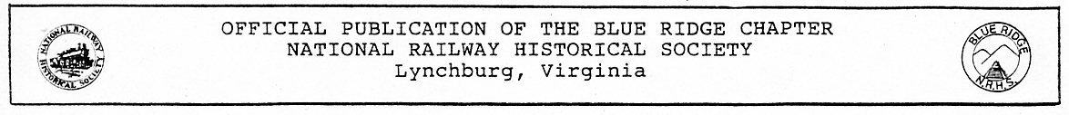

Blue Ridge Chapter, National Railway Historical Society
Minutes of Meeting - December 14, 2011

President Rick Johnson called the meeting to order at 7:35 p.m. and welcomed twenty members and one guest. We welcomed Gary Quale back from his recent illness. Minutes of the November meeting were approved as distributed. Treasurer John Tanner then reported.
Under Old Business Rick reminded members that dues were due! He then thanked Norris Deyerle for making all of the arrangements for another successful Christmas Banquet in Altavista, noting that everybody had a great time. Thanks were also given to John Tanner for the excellent beverages! Rick reminded members that the Kemper Street Station Christmas gathering is December 17th. Gary Quale said a few words about the recent Smith Mountain Lake model railroad layout tour that was part of their Christmas celebration and pointed out several things we might consider doing as part of our own Lynchburg Rail Day.
There was no report from the Vice-president. The National Director reported that here was nothing from National, but mentioned a feature article about the Buckingham Branch in the new issue of Trains Magazine. He thought Ed Bryant might be a potential speaker. Thanks were extended to Newsletter Editor Garland Harper for another great issue. Norris Deyerle read several letters acknowledging the chapter’s donations in the previous month and added that a $50 donation had been made to the Lane Memorial Methodist Church in Altavista in memory of Edward L. Rowland, our Christmas banquet caterer’s late husband. He also announced the Roanoke Chapter’s Christmas banquet would be the following Thursday and member John Siegle’s Christmas open house at his home layout next Saturday. No report from the Webmaster.
Rick announced that Ed Fielding will do the January program and Mr. Bob Flippin from the new High Bridge State Park will have a special program at the January Fun Meeting featuring recently discovered photographs of the 1914 bridge construction. Charlie Long presented two film features on steam railroads in Utah and Nevada.
Derek Wimberly won the 50/50 and the meeting adjourned at 8 p.m.

Tom Ledford, Secretary.

Special Fun Meeting - January 25, 2012

We have a special guest and program in store for you at our January 25 Blue Ridge Chapter “Fun Meeting”!
Bob Flippen with Farmville’s High Bridge Trail State Park will be our guest speaker for the evening and present his program on the 1913-14 construction of N&W’s famous “High Bridge” just east of Farmville, Virginia.
Bob is a Cumberland County resident living near High Bridge. He served as the Park's AmeriCorps volunteer in 2011 and was hired afterwards as an Education Specialist (Interpreter) on an hourly basis while still working in the ad department at The Farmville Herald.
Bob’s program will feature the outstanding photographs of Willis W. Vail, the resident engineer of the project! How Bob obtained these wonderful images follows in Rob Chapman’s story in The Farmville Herald of September 1, 2011 which I know you will find extremely interesting.
This is a program that you do not want to miss! If you know someone interested in railroad history or Civil War history, why don’t you give them a call or pass this newsletter along to them and invite them to join you for dinner and this terrific program on January 25!

Story By: Rob Chapman “The Farmville Herald” - September 1, 2011

It seems like you can find just about anything on eBay these days.
"One day (High Bridge Park Manager) Eric (Hougland) sent me an email saying that he was contacted by someone that these glass...photos...of High Bridge were available on eBay," Bob Flippen recounted. "And Eric knew that I'm really into eBay so I went and searched, but I was just thinking that it was gonna be the same old Timothy O'Sullivan reprints from 1865 after the war that you see all the time on eBay...After I had to raise my lower mandible off the floor, these were actual four inch by five inch glass negatives of the steel viaduct under construction in 1913 and 14-unknown views."
High Bridge, the centerpiece of a multiuse 31-mile trail, has its own mystique. Its history dates to the 1850s and the site even played a role in the waning days of the Civil War. Confederate forces attempted to burn-and to some degree succeeded- the structure to slow advancing Union soldiers.
But that bridge, supported by a series of brick piers some of which are now gone, went out of service in 1914, replaced by the scenic steel structure locals have long gazed at from a distance over the rural landscape. It is, relatively, in the middle of nowhere-a half a mile span of neither town nor community.
The last train to traverse the tracks over the bridge sadly rolled through Farmville on July 15, 2005 and, with rails and crossties now gone, a new trail opened tracking a lot of visitor attention.
Work on the bridge itself is still continuing and it is slated to be open for traffic sometime next spring.
But travel back in time to 1914 when the last bridge was being built. When steam locomotives huffed and puffed heavy loads of dirt on the steel lines and before name brand sneakers, DVDs, jump drives and America sent a man to the moon.
When engineers had to do creative things with what now seems archaic equipment.
If a picture says a thousand words, the recent discovery is pushing novel territory.
The eBay on-line auctions, Flippen recounted, basically consisted of a number for the negative, the name of the inscription on each envelope and a date, and a generalized description of High Bridge and how it has become a state park and a trail.
As it turns out, Willis W. Vail, the resident engineer of the project, took photographs of the replacement bridge in its construction process.
"Absolutely," Flippen says, when asked if it were one of the most extraordinary finds he has run across on eBay. "This is probably the best High Bridge find I've made since the original contract to build the original High Bridge in 1951 signed by Francis Carr and Christian Ehrman. They were the contractors who built the wooden superstructure over the brick pylons..."
He still has the original document with the hand-written specifications.
Flippen, who also works in The Herald's advertising department, collects ephemera-papers, things that don't typically last.
"I've bought, collected and sold old things all my life and there's certain situations you only get one shot," Flippen stressed. "There's only one of each of these. You only get one shot; you have to act."
He did just that, working to secure as many of the artifacts as possible-first through auction purchases and then working with the seller. His goal, with the support of the Friends of High Bridge, is that they will go to the High Bridge Trail State Park.
"Hopefully, the powers that be will see this and recognize that these photographs combined with the engineering news article of September...10, 1914 that details the construction of the steel viaduct, that together they will complement themselves to create a fascinating exhibit for the visitor's center which, hopefully, may be built just in time for the 100th anniversary of the bridge," Flippen said.
Which is not that far away, 2014.
Jo Smith, a local historian on the subject, has long been fascinated with the bridge and has written the booklet A History of High Bridge. She had located the engineering article (which she had passed onto Flippen) some years ago and recognized the photos.
"...I was just overwhelmed," she said. "I knew exactly when he had sent me a couple...where they had come from and, of course, he did too at that point. Because I had shared that article with him way back when I first started my research-located that engineering news..."
One thing she is particularly interested in among the collection is the one that depicts the mules and scoops used in building the abutment.
"Because I have in my booklet the names of people who were involved in that," she says. "Some were...just teenagers that were local farmers and they used their mules and their scoops to help build that abutment, so that one was really something that interests me. And the cleared land that was down there-he shared with me one this week that...if you're on the what I call the western end...the Farmville end of the bridge, you can actually see the Smith's house and one of the tobacco barns on the place."
That house, she believes, was built about 1912.
It also shows an open land below the bridge, now forested with trees stretching to the sky.
"Just to think that these negatives had been somewhere all these years-I mean we're looking almost like a hundred years that these negatives were somewhere else. And to have them show up on eBay is just a miracle that they were located," Ms. Smith says.
She would later offer, "Did I say wow?"
"What have I learned? Oh my gosh. How massive a project it was," Flippen said. "The earth removal alone to build the approaches for the new bridge, they had train car dump loads-and you see pictures of them in these-that the pedestals that you see where the steel sits upon is just the tip of an iceberg showing. The average pedestal is over 20 feet tall. The ones by the river and by the bridge abutments

are 32 feet tall and, once they were cast, the dirt was piled up all around it."
Flippen had a description of the work at the site from the copy of the engineering magazine, but the photographs and the written work re-enforce one another in the magnanimity of the project and how it was done.
There was 13 months of preparation work before the steel was placed. The half a mile of the steel bridge or 2,400 feet started the first week of April 1914, with completion in the first week of June. Traffic was diverted from the old to the new bridge on June 22, 1914.
The photos detail a steam engine used on site, the manufacture of pylons, and that a steam-powered dredge was used in the Appomattox River to collect sand for concrete produced on site. The dredge was named the "Titanic," perhaps a tribute to the real Titanic that sank when it hit an iceberg in the Atlantic Ocean in 1912.
"And in these glass negatives is probably the only known picture of both bridges standing side by side with the tracks still intact," Flippen said.
Almost as soon as the new bridge was built, the steel from the old bridge was taken down-the end of an era, and the beginning of another.
In all, Flippen has secured about 70-75 of the glass negatives-although he speculates there were (going by the negative numbers) about 120. And while he has much of the collection, others are now detached from the whole, thanks to other eBay buyers.
Vail was quite detailed in his work. Each of the glass negative sleeves specify a negative number, date the picture was taken, time of day, weather, lens aperture for the camera and a brief description of the photo.
Meticulous, like an engineer.
"I think it's a wonderful thing we've got in somebody's possession in this area," Ms. Smith said. "Not to have 'em distributed somewhere where it wouldn't be as meaningful."
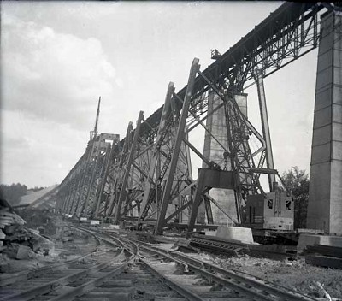
Hougland offered, "...What a find, I guess, to be able to have some insight into how the construction happened on the bridge. Some of those photos of the work camp with the tar paper shacks and things...I think it's just a tremendous resource to have an idea how it all happened. I mean, we haven't been able to find very much documentation about the construction of it so to have that visual story is pretty meaningful."
Houghland noted that they are working with Prince Edward County to have an exhibit about the time of the opening of the bridge that would be displayed in the Visitor's Center in Farmville. They could show some of the photos as part of the exhibit.
"But even the glass negatives and the sleeves that they're in are a part of history," Houghland said.
Flippen believes that there is a mysticism involved around High Bridge. He noted that it carries two major themes of American history - railroad transportation and American Civil War. It's somewhat mystical because of its seclusion.
"...The entire trail's important, but the truth of it is...High Bridge is the iconic central point of the park and...we're real anxious to get it open and available for use," Hougland said.
Houghland points to a lot of things that make it special-the view, history associated with it - when the original bridge was constructed, the Civil War history, and transportation history.
"But, probably the one thing is just the - size just seems like too little of a word. I mean the immensity of it," he said. "There's not too many places that are gonna boast a half a mile long bridge that's 160 feet high that you can cross as a pedestrian, a bicyclist or walking your horse across."
And now, thanks to eBay and some watchful eyes and a good tip, a chunk of its history is traveling home, too.

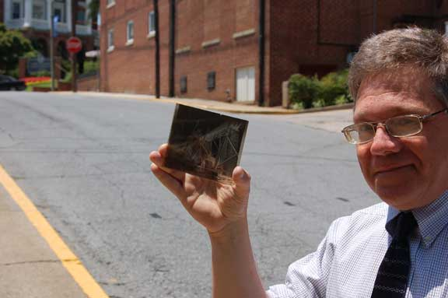

High Bridge construction. c. 1914 Bob Flippen holds the glass negative

More railroad-related newspaper articles from 100 years ago, including the construction of the Kemper Street station, which celebrates its centennial in 2012, follow.

NEW SOUTHERN DEPOT
---------
Contract Is let to Local Builders,
Who Will Begin Work Soon
(The Lynchburg News. Sep. 1, 1911)

The contract for the new Southern Railway passenger station on Kemper street has just been let by the officials of the railroad to John P. Pettyjohn & Co., of this city, and the work will be started as soon as the excavation, which is now well under way, is completed. The contract for the erection of the station calls for its completion in five months from the time the work is commenced.
It was learned yesterday afternoon that the contractors on the excavation have about two weeks of work yet before the site can be said to be ready for the actual structural operations to attain a start. If the contractors are able to begin their work by September 15, and the work is done in contract time, this means that it will be hardly possible for the new station to be used before February 15, and that patrons of the system will have to put up with the temporary station on Buchanan street in the meantime, a condition which is by no means inviting. This delay has been occasioned by the change in sites, for if the company had not been induced by the city council to locate the station nearer the street car line it would no doubt be ready for use about this time.
It is understood that the contract price for the station is about $55,000, and that the building will be one of the prettiest and most convenient to be seen anywhere on the main line of the Southern system. The structure will be a two-story affair, the ground plan being 41 x 140 feet in dimensions. It will be located about 200 feet from Park avenue, on Kemper street, and will be accessible from the street car line. The main floor is to be for the mail, baggage and express. The waiting room will be on the street level, 41 x 110 feet in dimensions, and from the cross-over two umbrella sheds, each 600 feet long, will lead over the tracks and walkways.
The building will be constructed of red velvet brick and will have a roofing of green tile. Stairways will lead from the tracks to the waiting room above. The plans for the erection of the station make it appear as though Lynchburg will be provided with a building which will fulfill all the requirements to which it may be subjected, and while not pretentious, it will be attractive in construction and will be roomy and large. It will not be unlike the Norfolk and Western station in Roanoke.

THE RAILROAD’S HEAVY TOLL
(Washington Herald)
(The Lynchburg News. Sep. 1, 1911)

It seems almost incredible that there should have been over 7,700 persons killed by and upon the railroads during the present year, with more than 55,000 persons injured through the same agency. These are the figures, however, of the Interstate Commerce Commission, which is now required by law to keep adequate record of railroad accidents.
While credit must be given to the railroads for every intention to prevent accidents, and while due allowance must always be made for the fallibility of human agency, the fact still remains that the minimum of sacrifice of human life has not been reached. The Interstate Commerce Commission will in time be able to determine definitely where the fault lies – whether in unnecessary and reckless speed or in lack of adequate inspection of roadbed or rolling stock or through insufficient appliances for safety. These causes, or others, may explain why railroad accidents occur with such frequency.
The proportion of fatalities in the United States is much greater than abroad. It is true that we do business upon a larger and faster scale, but, none the less, it ought to be done with a maximum of safety not now enjoyed.

NO BAGGAGE DELAYED
--------
Railways Perform Remarkable Feat in Bringing Baggage to College
(The Lynchburg News. Sep. 26, 1911)

The railways handling the baggage for the students at the Randolph-Macon Woman’s College performed the remarkable feat of bringing 600 trunks to Lynchburg without having one go astray.
When it is recalled that these students come from all parts of the United States, and that nearly all of them came in two or three days this performance is a remarkable one.
The baggage was handled to the college from the railway stations by the Long Transfer Company, in good time and without inconvenience to the young ladies.

LENGTHEN THE TUNNEL
-------
Southern Railway Arranges to Reopen
Dearing Street in Rivermont
(The Lynchburg News. Sep. 26, 1911)

The engineering department of the Southern Railway has let a contract to Stewart & Jones, of Rock Hill, S.C. for the extension of the southern end of the Rivermont tunnel and the work will be started shortly.
This contract was made necessary to permit the reopening of Dearing street, which is deflected around the work since it started nearly five years ago.
It is understood that a high wall will also be built above the end of the tunnel in order that the street may be kept from gradually crumbling away and traffic will be protected by a fence at the top.
This contracting firm has just about completed the viaduct over the new railway line, which will shortly mean the reopening of Bedford avenue.

MORE DELAY FOR STATION
-------
Change in Excavation Plans
to Tie Up Southern Longer

(The Lynchburg News. Oct. 10, 1911)

Another change in the plans for the excavation for the new passenger station for the Southern Railway in the West End will, it was reported last night, be the means of delaying the actual start on the work of the station for several weeks at least.
It was learned late yesterday afternoon that orders have been issued by the management of the system for the removal of more earth between the railway and Park avenue than was originally contemplated and this will take several weeks to complete.
The contract for erecting the station was let more than a month ago to John P. Pettyjohn & Company, of this city, which firm will be ready to start work as soon as the steam shovel can be gotten away.

Christmas Get-Together at Kemper Street Station was enjoyed by many. About 40 Chapter members and guests assembled at Kemper Street Station December 17 on the occasion of the Chapter's annual get-together. A few pictures follow. Thanks to Skip Hansberry for the outdoor shots. Your Editor took the interior view.
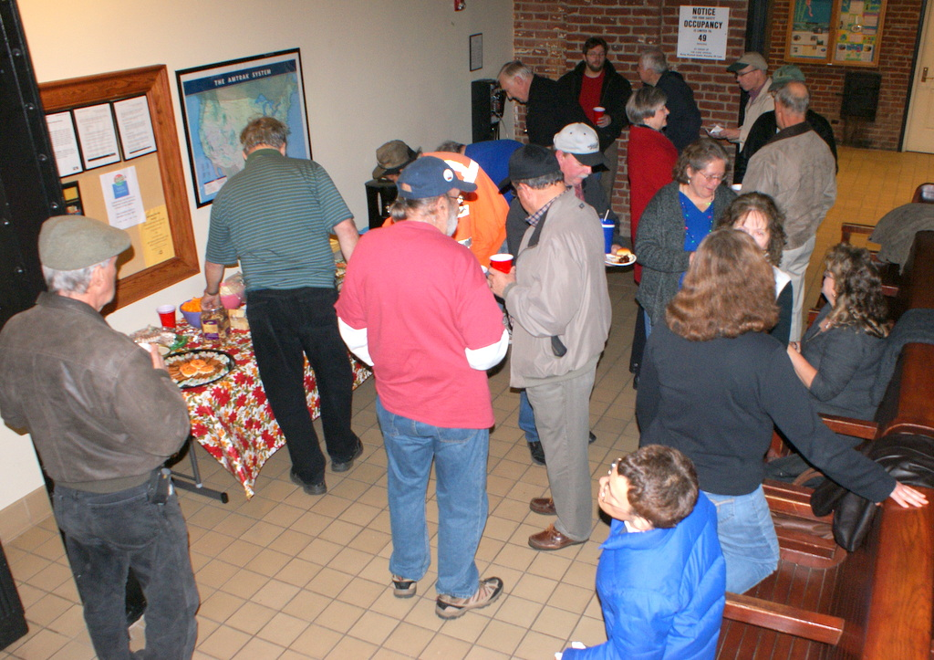
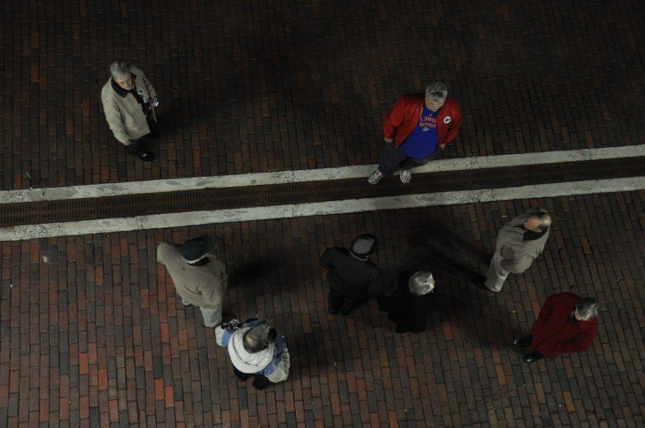
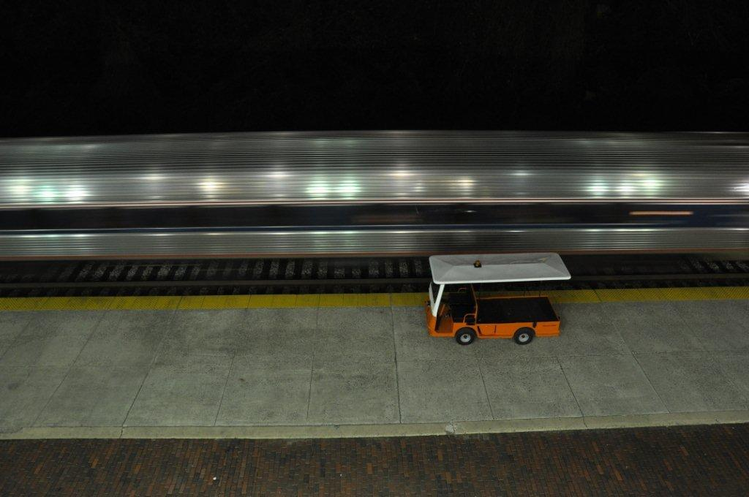
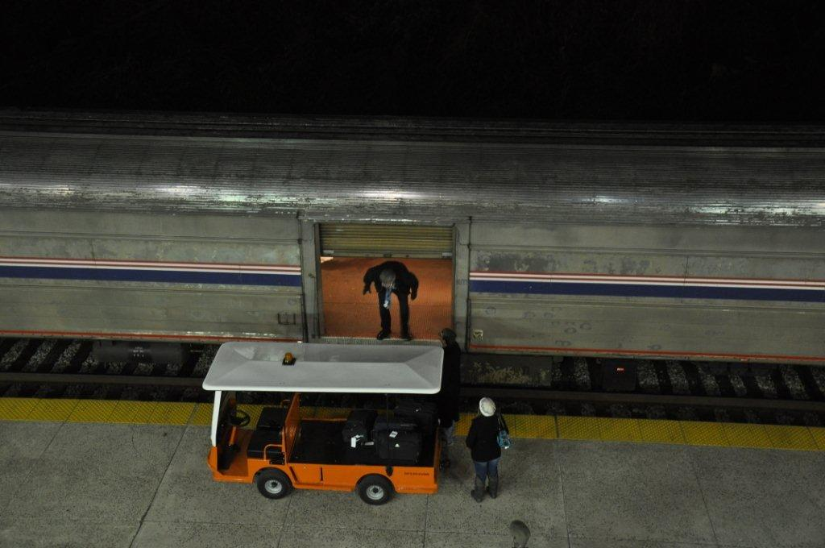

Clockwise from top left: Blue Ridge Chapter members enjoy food and fellowship in the Kemper Street waiting room. Blue Ridge Chapter members on the platform viewed from above while Amtrak #19 makes its stop. Train #19 baggage work. Train #19 is a blur as it leaves LYH.

Blue Ridge Chapter, NRHS 2012 Calendar of Events 54TH Anniversary of the Blue Ridge Chapter
A Virginia’s Rail Heritage Region Partner
Compiled By Norris Deyerle,Blue Ridge Chapter, NRHS Chairman of Virginia’s Rail Heritage Region Partners
Newly added events since last month printed in “Bold Italics”.

Notice: The NRHS is the lead member of a new group of railway heritage groups and preservationists that list their upcoming events on their new website, RHICalendar@nrhs.com. I urge our friends with the other railway historical groups and museums to take advantage of this new NRHS service. There is no cost to subscribe to this service. This is a website that will help us all get the word out about our events!
January 2012
Now Through 1-08-12: Bevell’s Ace Hardware in the heart of downtown Blackstone, Va. will present its annual “Trains For Christmas” commencing the Friday after Thanksgiving Day thru January 8, 2012. “O” Gauge trains will operate during normal store hours. Free and open to the public. This model train layout is one of the nicest that you will ever see! It’s displayed so small children can enjoy it. Courtesy of Robin R. Shavers
01-07 & 08-12: {Saturday & Sunday} 2012 NRHS Winter Conference, Williamsburg, Va.
01-11-12: {Wednesday} BRC, NRHS Monthly Meeting, Ed Fielding slide show
01-15-12: {Sunday} Virginia Train Collectors Train Meet, Nansemond-Suffolk Academy, 3373 Pruden Blvd. {Rt. 460} Suffolk, Va. 23434, Contact: Stuart Gordon, 804-798-3739 between 5:00 pm & 9:00 pm. Info: www.vatraincollectors.com
01-21-12: {Saturday} Great Lehigh Valley Train Meet, Location: Merchant Square Mall. Info: http://valleygoto.com, email: info@lehighvalleytrainmeet.com
01-25-12: {Wednesday} BRC, NRHS “Fun Meeting”, Special Guest Bob Flippen, “N&W High Bridge 1914 Const. Photos”
February 2012
02-08-12: {Wednesday} BRC, NRHS Monthly Meeting, Dale Diacont slide show “2011 Year in Review”
02-18 & 19-12: {Saturday & Sunday} C&OHS “George Washington’s Train Show” Sat. 10:00 am – 4:00 pm, Sun. Noon – 4:00 pm, Admission $5.00 per person, Clifton Forge Armory, Clifton Forge, Va. Info: 540-862-2210
02-25 & 26-12: {Saturday & Sunday} Spring Thaw Train Show, Allentown Fairgrounds Ag Hall, Allentown, Pa. Info: www.allentowntrainmeet.com
March 2012
03-14-12: {Wednesday} BRC, NRHS Monthly Meeting, Wayland Moore presentation
03-28-12: {Wednesday} BRC, NRHS “Fun Meeting”, Aubrey Wiley, “Restoring A 100 Yr. Old VGN Motor Car”
April 2012
04-11-12: {Wednesday} BRC, NRHS Monthly Meeting, Skip Hansberry Slide presentation
04-21-12: {Saturday} Buckeye Railroadiana Show, Ohio Expo Center, Info: www.gserr.com
May 2012
05-09-12: {Wednesday} BRC, NRHS Monthly Meeting, Kurt Reisweber presentation
05-23-12: {Wednesday} BRC, NRHS “Fun Meeting”
June 2012
06-13-12: {Wednesday} BRC, NRHS Monthly Meeting, Steve Hutchison presentation
06-18 {Monday} Through 6-24-12: {Sunday} NRHS National Convention 2012, Cedar Rapids, Iowa, Info: www.nrhs.org
06-21 {Thursday} Through 6-24-11 {Sunday}: N&WHS 2012 Convention, “Mainline To Norfolk”, Location: Lynchburg, Va. Info: conv2012@earthlink.net and www.nwhs.org, Contact: Charlie Long, H. {434} 239-3521, C. {434} 660-6989
06-23-11: {Saturday} North Carolina Railroad Show, Location: Metrolina Expo Trade Center, Info: www.gserr.com
July 2012
07-11-12: {Wednesday} BRC, NRHS Monthly Meeting, Fred Mayer presentation
07-25-12: {Wednesday} BRC, NRHS “Fun Meeting”
August 2012
08-08-12: {Wednesday} BRC, NRHS Monthly Meeting, Dale Diacont, Green Mountain, Vermont Railroad, Mt. Washington Cog Railroad and the D&H.
08-11-12: {Saturday} Lynchburg Rail Day 2012, BRC, NRHS
September 2012
09-12-12: {Wednesday} BRC, NRHS Monthly Meeting, Norris Deyerle presentation
09-16-12: {Sunday} BRC, NRHS Summer Picnic
09-26-12: {Wednesday} BRC, NRHS “Fun Meeting”
October 2012
10-10-12: {Wednesday} BRC, NRHS Monthly Meeting, Kurt Reisweber
November 2012
11-14-12: {Wednesday} BRC, NRHS Monthly Meeting, Wayland Moore
11-21-12: No November “Fun Meeting” due to Thanksgiving
December 2012
12-01-12: {Saturday} BRC, NRHS Annual Christmas Banquet, Altavista, Va.
12-12-12: {Wednesday} BRC, NRHS Monthly Meeting, Rick-2 Johnson, presentation
12-22-12: {Saturday} BRC, NRHS Kemper Street Station Christmas Gathering
Railroad Related Events Information: Visit: www.varailheritage.org, www.vmt.org, www.linkmuseum.org, www.roanokenrhs.org, www.nwhs.org, www.cohs.org, www.vatraincollectors.com, www.klnl.org, www.nhvry.org, www.norfolksouthernhs.org, www.RailServe.com, www.trains.com, www.TrainFinder.com, www.gserr.com or RHICalendar@nrhs.com.
Norfolk Southern/TVRM Steam Excursion Website: http://www.21stcenturysteam.com
Steam Train Events in the United States and Canada: www.diary.svsfilm.com
Railroad Historical Information And Related Photos: www.hawkinsrails.net
Danville & Western Ry. Website: Railway operated in Southwestern Virginia between Danville and Stuart. http://southern-railway.railfan.net/dw/
Additional links to other NRHS Chapters, Railroad Historical Societies and Museums available at www.blueridgenrhs.org
Virginia Museum Of Transportation Rail Cam: http://www.nwhs.org/cam/vmt
Roanoke, Va. Rail Cam: http://128.173.197.94:443/RRCmov
Lynchburg Rail Day 2012 {Saturday} August 11, 2012
CHAPTER OFFICERS AND STAFF

President Rick Johnson, 104 Mowry Ln. Lynchburg, VA 24502
434-660-1113 notch8@aol.com
Vice President Charlie Long, 106 Pacos St., Lynchburg, VA 24502
434-239-3521 cwlongjr@mindspring.com
Secretary Tom Ledford, 2186 Woodcrest Dr., Lynchburg, VA 24503
434-384-2013 tomledford@hotmail.com
Treasurer John Tanner, 209 Pocahontas Dr., Forest, VA 24551-1235
434-525-1318 flytrains@ verizon.net
National Director Earl Guthrow 1909 Quarry Rd. Lynchburg, VA 24503
434-384-2583 meguthrow@verizon.net
Editor Garland R. Harper, 3920 Harbor St. Lynchburg, VA 24503 434-384-7210 GRHarper@aol.com
Historian Rick Johnson, 104 Mowry Ln. Lynchburg, VA 24502
434-660-1113 notch8@aol.com
Webmaster John Siegle 1225 Krise Cir. Lynchburg, VA 24503
    - jas65@comcast.net
Editor Staff E. Norris Deyerle, Jr. 744 Chinook Pl., Lynchburg, VA 24502
434-237-4912 railcow@msn.com

The BLUE RIDGE DISPATCHER is published by the Blue Ridge Chapter, National Railway Historical Society. Opinions expressed are those of the editor and contributors and do not necessarily reflect the views of the Blue Ridge Chapter or the National Railway Historical Society unless otherwise stated.

Blue Ridge Chapter, NRHS
P. O. Box 11731
Lynchburg, VA 24506-1731
www.blueridgenrhs.org

LYNCHBURG RAIL DAY 2012. SATURDAY, August 11, 2012.

