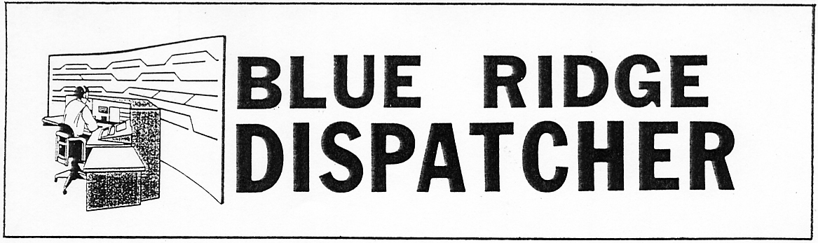
Vol. 19 July 2011 No. 7

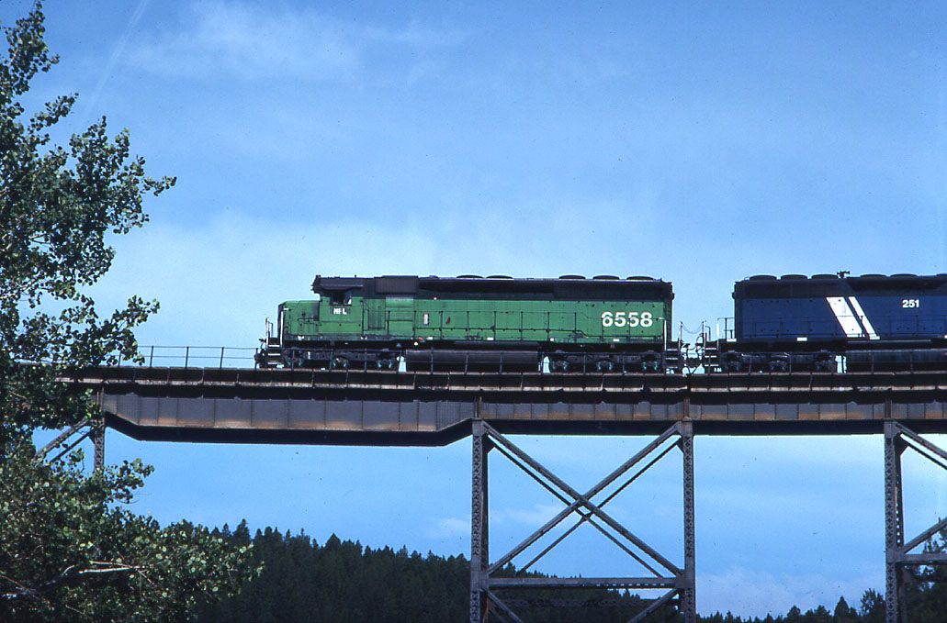

Montana Rail Link train crossing Austin Creek trestle on Mullan Pass near Helena, MT. April 1991.

Chapter member Fred Mayer presents the program for the July meeting of the Blue Ridge Chapter, NRHS. His program, “Railroads of Montana”, will include scenes selected from his video collection covering Montana Rail Link, Milwaukee Road and Burlington Northern. Having grown up in Montana Fred will offer “color commentary” on the history, geography, and personal experiences relating to the video scenes presented. Montana offers great railroading and spectacular scenery which should be enjoyable to all,
so plan to be present!

Wednesday, July 13, 2011. 6:00 p.m.
Charley’s Restaurant 707 Graves Mill Rd. Lynchburg, VA

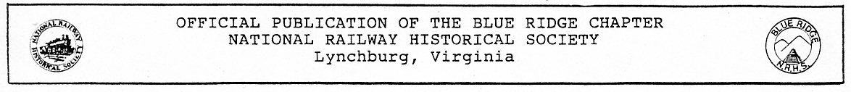

Blue Ridge Chapter, National Railway Historical Society
Minutes of Meeting - June 8, 2011

President Rick Johnson called the meeting to order at 7:35 p.m. at Charley’s Restaurant and welcomed 19 members and 4 guests, including Peggy Deyerle, Betsy Gardner, Denise Mays and Jan Hawkins. Rick welcomed member Ed Fielding after a lengthy absence. Gary Quale has undergone another knee replacement and was recuperating well so far. Rick also announced that Bob Carpenter’s daughter June had been appointed to a church in Amelia, VA, and Bob would be moving there with her. It was also noted that Ed Rowland had died. He was the husband of Geneive Rowland, our Christmas banquet caterer. The members expressed their condolences to Mrs. Rowland and her family and made a $50.00 contribution to their church in Altavista. Minutes of the May meeting were approved as distributed and the Treasurer then reported.

There was no Old Business.

There were no reports from the Vice President, National Director, Newsletter Editor or the Web Master. Chairman of the Virginia Rail Heritage Region Project, Norris Deyerle reported on Lynchburg Rail Day noting that help will be needed and chapter members could still rent tables at a reduced rate. Lynchburg Rail Day posters and fliers are available for distribution.

Lee Hawkins discussed an Amtrak regional trip on Saturday, July 23rd to Manassas as part of the Battle of Bull Run commemorations. Tickets are about $42.00 and there would be a 4-hour layover. Rick announced he would be presenting the evening’s program, due to Steve Hutchinson’s illness. The July program will be presented by Fred Mayer on the Railroads of Montana. The July 27 Fun Meeting would be presented by David Helmer covering his railroad experiences in Viet Nam. Meeting adjourned at 8:51 pm.

Tom Ledford, Secretary

July 1, 2011: a bad day for Amtrak in Lynchburg – Two unrelated railroad events made for some very interesting train watching in Lynchburg on July 1. Locally, it was necessary to cancel the Lynchburg Regional train on this morning due to locomotive failure. Approximately 145 passengers were scheduled to ride the train out of Lynchburg. Three chartered busses from Abbott Bus in Roanoke were substituted for the train and whisked the people away.
When things have gone wrong in the past with motive power on the Regional train an engine has been taken of the northbound Crescent and placed on the Regional. On this particular day, however, the Crescent, train #20, had been delayed in the deep south by an NS freight train derailment in Akron, AL, the day before and was running TWELVE hours late! It was of no help this day.
The passengers on the ill-fated train had been taken care of with the busses. They were gone. However, the equipment from the cancelled train remained in Lynchburg. Disabled locomotive #16 and the nine cars were still occupying the storage track at Lynchburg. This trainset needed to get out of the way in order to make room for the southbound Regional which would arrive at 8:30 p.m.
What was done to solve the problem made for the interesting train watching. The Crescent arrived into Lynchburg about 6 p.m. The disabled engine from the Regional train was taken off its train and set aside on one of the additional storage tracks at Kemper Street. After that was completed, the Crescent pulled past the switch leading into the storage track and then backed into the storage track and coupled up to the cars of the Regional. What resulted was a nineteen-car passenger train! The Fifth Street Bridge made for a great place to watch all the activity and quite a number of nice pictures were made. Some of these follow. Off-duty Amtrak ticket agent Glen Lawhorne shot a video of the monster train crossing the James River and it can be seen at http://www.youtube.com/watch?v=QcVFvhyY1WA
With the departure of the Crescent the cars of the Regional were now gone. The bad engine, however, remained in town over the weekend. It was sent back to Washington on Monday morning’s Regional train dead-in-tow. To reduce the chance that something might go wrong with the move an engine was taken off the Crescent and added to the Regional’s consist. Thus, Train #156 on July 4 left town with three engines, #169 off the Crescent, engine #16 dead, and engine #72.
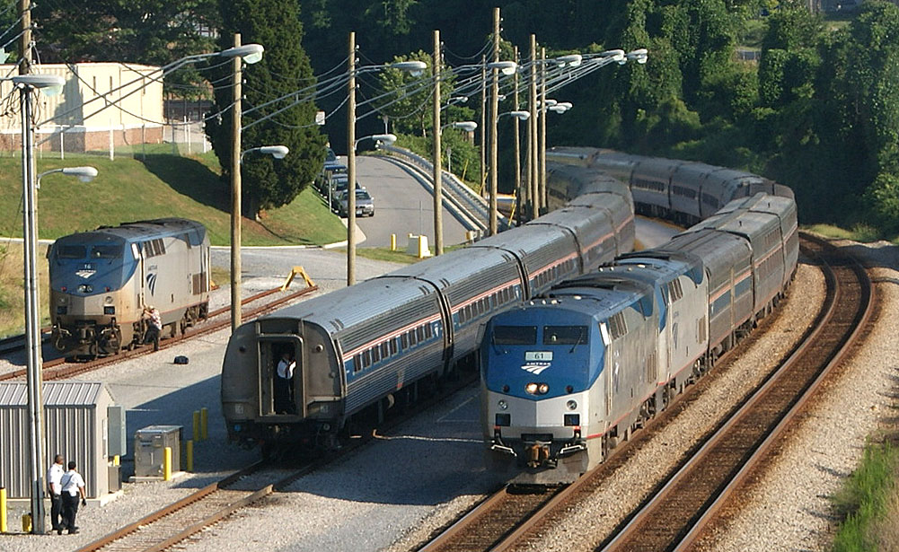
Equipment manipulation resulting from Train #176’s annulment July 1.
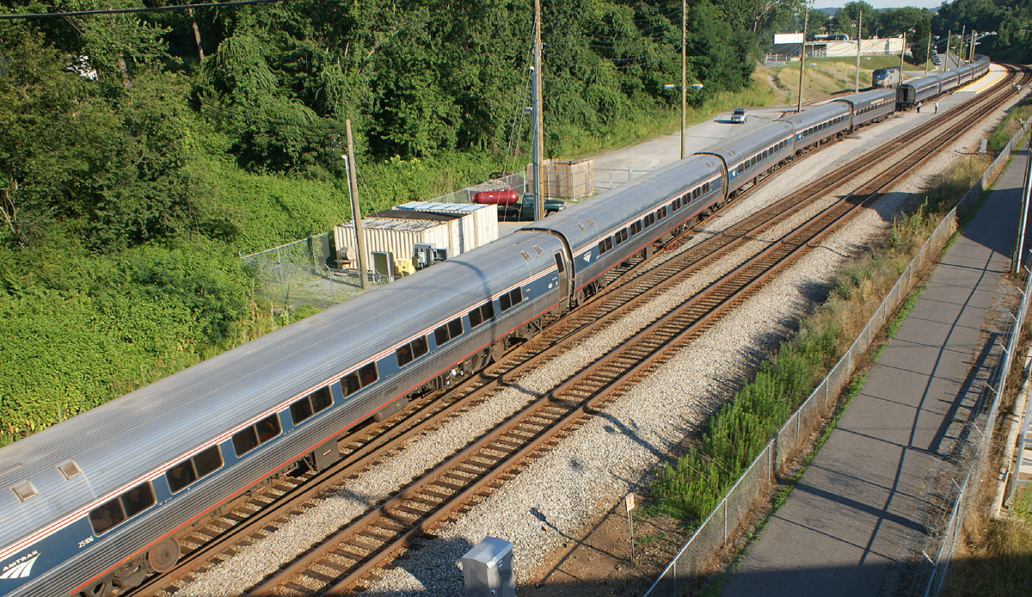

2. 1.
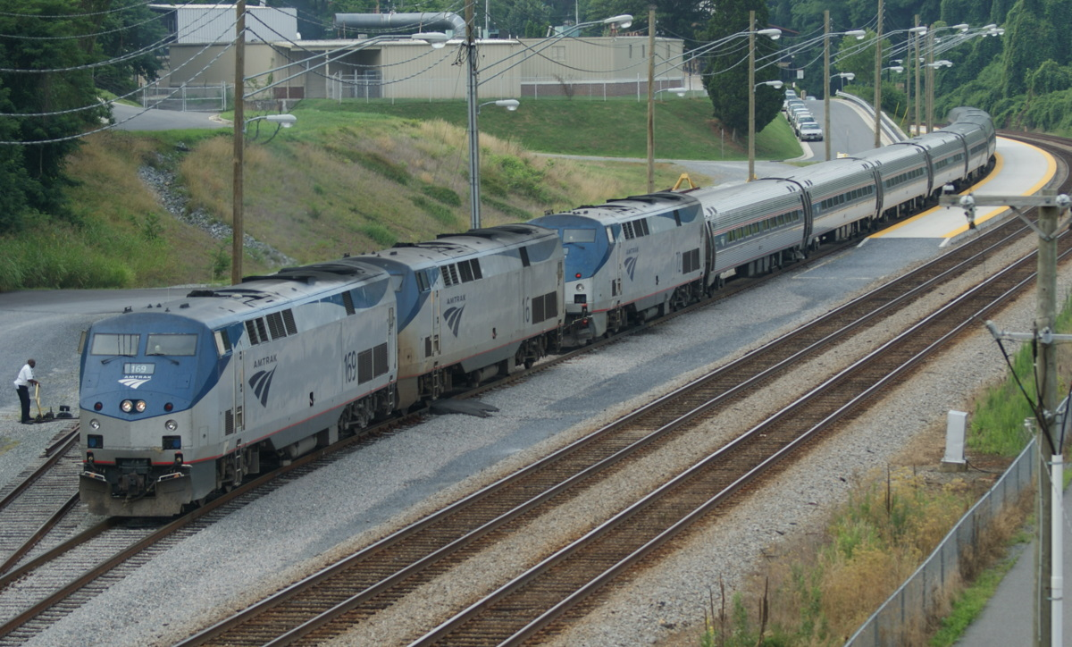
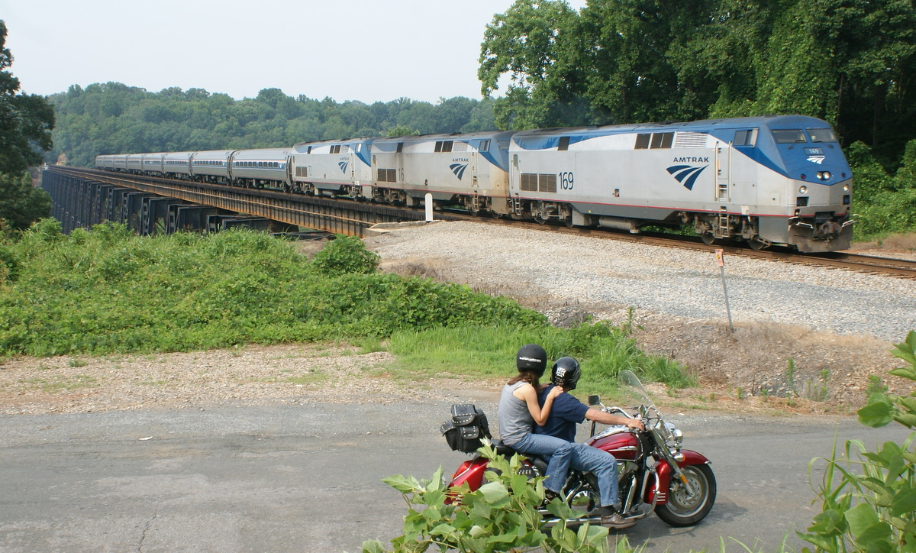

3. 4.
1. July 1: Bad-ordered engine #16 is set out to the left, the Regional’s cars remain in the Lynchburg storage track, and a 12-hour late train #20, The Crescent, eases north to rescue the train. 2. The rear of the Crescent is about to make a coupling with the Regional’s cars resulting in a 19-car train. 3. July 4: Engine #169 off the Crescent that morning and bad-ordered engine #16 are added to the Lynchburg Regional train #156. 4. Two bikers watch #156 at River Road in Amherst County. Photo 1. by Lee Hawkins. Photos 2. 3. 4. by G. Harper

New train on the CSX James River – The semi-permanent reroute of CSXT intermodal trains Q130 and Q139 via the former C&O has occurred. Tunnel enlargement work along the former B&O in northern West Virginia is the reason. The trains run between New Baltimore, OH and Portsmouth, VA, most days of the week. The Q139 that originated in Portsmouth on June 21 was the first train to be rerouted and was seen passing through Lynchburg about 3:00 p.m. on June 22. The trains have settled into a routine, with Q139 going west through town between 10 a.m. and 2 p.m. and Q130 going east between 3 p.m. and 6 p.m.
Pictured below is a CSXT container on Q139 behind Reusens Dam. Regular intermodal traffic on the James River is quite a welcomed change of pace from the usual coal and grain traffic. Photo by G. Harper
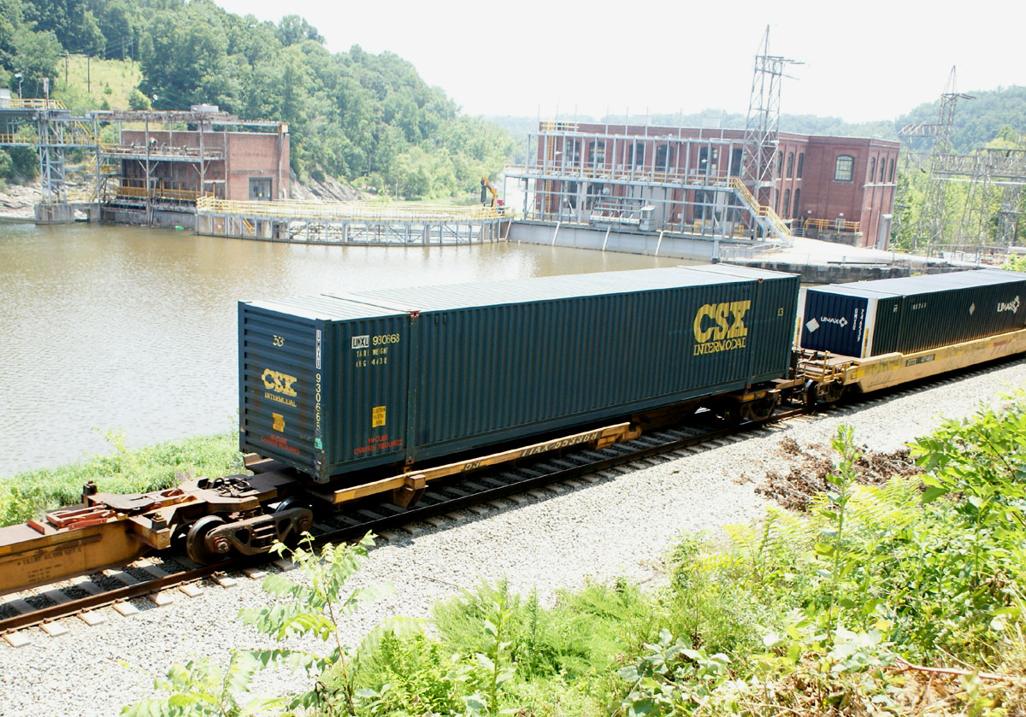

Blue Ridge Chapter, NRHS Presents
The 33rd Annual Lynchburg Rail Day 2011
9 am – 4 pm, Saturday August 13, 2011
Boonsboro Ruritan Club
1065 Coffee Road Lynchburg, Virginia 24503

Lynchburg Rail Day 2011 White Elephant Table
Guidelines Information And Release Form

Thank you for your interest in allowing the Blue Ridge Chapter, NRHS to sell your railroad related items on a consignment basis.

Our chapter will be accepting railroad related items for consignment at our designated White Elephant Table “check-in” area at the Boonsboro Ruritan Club on 1065 Coffee Road, Route 644, off US 501 North, Lynchburg, Va. 24503. Go to www.blueridgenrhs.org for detailed directions to this location. Do not rely solely on GPS maps to get to the Boonsboro Ruritan Club! The GPS maps may be incorrect! “Check in” times are Friday, August 12, 2011 from 4:00 pm to 7:00 pm and Saturday, August 13, 2011 from 8:00 am to 10:30 am. These are the only times that there will be White Elephant Table workers available to help you check in your items. Please note that there will be no items checked in unless you have your items clearly priced and marked as described in the following guidelines.

Guidelines

- All items must be railroad related. Examples include, but not limited to, model railroad locomotives, rolling stock, track, transformers, structures, railroad memorabilia, lanterns, locks, keys, china, timetables, etc.

NO MAGAZINES will be accepted unless they are securely bundled and priced by the
BUNDLE. Collectible hard and soft cover books are encouraged and gladly accepted.

- All items must be clearly identified with the seller’s three initials and an item number written on a price sticker secured to the item for sale.

- A master list to be left with the White Elephant Table staff must include what your three initials are, item description, item number, and the selling price. You must price your items. This is not an auction. There are no exceptions. No master list, no consignment. Please have your name, address, phone numbers and email address clearly printed on your master list so you can be contacted about any future shows.

- Consignment fees: 20% of the seller’s marked price. There will be a minimum commission payable to the Blue Ridge Chapter of $1.00 per item or group of items.

Example 1: A single item has the selling price of $10.00. If sold, the seller received $8.00 and the Blue Ridge Chapter, NRHS receives $2.00

Example 2: A single item has the selling price of $4.00. 20% of $4.00 is $.80. Since the minimum handling charge is $1.00, if this item is sold, the seller will receive $3.00. It is recommended to bag groups of small loose or inexpensive items together to sell them as a single item. This may save you money by avoiding multiple minimum handling charges. No charge to you if we don’t sell your item{s}. It’s Free!
Please mark all of your prices using whole dollar amounts.

- Any unsold items not picked from the White Elephant Table by the end of the show will become the property of the Blue Ridge Chapter, NRHS.

- Instructions for receiving payment: The White Elephant Table closes at 3:30 pm the day of the show. Sellers may collect the money due to them after the White Elephant Table workers finish calculating the money due to you from the sales of your items. This will take place as close to 4:00 pm as possible depending on when the White Elephant Table workers get the Blue Ridge Chapter, NRHS commissions calculated. NO EXCEPTIONS. The White Elephant Table workers don’t have time to calculate your portion during the day. You can pick up your items at any time providing that there is someone available to help you check your sold items off of your master list. If you are unable to pick up your money, a check will be mailed to you if you supply a SASE.

- Disclosure Statement:
Every precaution will be taken to assure the safe handling of your items. Brass locomotives and other expensive items will be shown only with the assistance of a White Elephant Table staff member. If an item needs to be test run, it will only be done with a White Elephant Table staff member or seller present. No exceptions will be made.
The Boonsboro Ruritan Club, the National Railway Historical Society, the Blue Ridge Chapter, NRHS or any member of these organizations assume no responsibility for incorrectly priced, damaged, or stolen items. The risk rests entirely upon the seller/consignor.

Thank you for allowing the Blue Ridge Chapter, NRHS to consign your railroad items. Lynchburg Rail Day 2011 Train Show Chairman: Barry Moorefield, Questions? Email Barry at bmopar@verizon.net . Phone: 434-821- 2174.
I have read and understand the guidelines and regulations written above and agree with them as written.

Connecting shuttle service between Roanoke and Lynchburg Amtrak set to begin – Roanoke Valley Metro has announced it will begin its “Smartway” bus service between Roanoke and Kemper Street Station on July 19. The service is designed to make it easier for people in the Roanoke area to connect with the Lynchburg Regional Amtrak service to the Northeast. Two round-trips per day will be made, one in the morning to connect with trains #176/#156, and one in the evening connecting from trains #171/#147/#145. The service will originate in Roanoke Monday-Thursday and will originate in Blacksburg Friday, Saturday, and Sunday. The fare is currently set at $4/trip. Complete details can be found by visiting their website at www.smartwaybus.com

Ed. Note – While I am happy that the service is set to begin, I do have a few concerns about it. Anything to reduce the number of cars coming to Kemper Street is welcomed, for sure. I understand they will be operating a 16-seat mini-bus and that no reservations are required. What will happen if twenty people with baggage show up at the Civic Center expecting a ride to Lynchburg? What then? What happens if the bus breaks down en route to Lynchburg and train connections are missed? Who’s going to be responsible for that, if anyone. I guess these are things we’ll have to face as they arise. In any event, it will be interesting to see how it plays out and how used the service will be.

Blue Ridge Chapter, NRHS 2011 Calendar of Events
53rd Anniversary of the Blue Ridge Chapter, a Virginia’s Rail Heritage Region Partner
Compiled by Norris Deyerle,
Blue Ridge Chapter, NRHS Chairman of Virginia’s Rail Heritage Region Partners

Newly added events since last month printed in “Bold Italics”.
Notice: The East Broad Top Railroad National Historical Landmark has many events planned for the rest of 2011. Info: www.ebtrr.com. Their neighbor next door, The Rockhill Trolley Museum also has events planned. Info: www.rockhilltrolley.org. The NRHS is the lead member of a new group of railway heritage groups and preservationists that list their upcoming events on their new website, RHICalendar@nrhs.com. The EBRR and the Rock Hill Trolley Museum both have their events listed along with dozens of other groups. I emailed our LRD 2011 Media Release to the Railway Heritage Initiative Planning Calendar. I urge our friends with the other railway historical groups and museums to take advantage of this new NRHS service. There is no cost to subscribe to this service. This is a website that will help us all get the word out about our events!
Steam Train Events in the United States and Canada! www.diary.svsfilm.com

July 2011:
06-26 through 7-31-11: “Hollywood’s Star Cars”, Over a month long exhibit only at the Virginia Museum Of Transportation, Roanoke, Va. Info: www.vmt.org
07-10-15-11: {Sunday through Friday} NRHS RailCamp at the Steamtown National Historic Site, Scranton, Pa. Info: www.railcamp.com/offerings
07-13-11: {Wednesday} BRC, NRHS Monthly Meeting, Fred Mayer
07-16-11: {Saturday} 2nd Annual Lancaster Lock Show, HOST Resort, Lancaster, Pa. Info: www.lancasterlockshow.com, Posting courtesy of Key, Lock & Lantern.
07-21-11: {Thursday} Roanoke Chapter, NRHS Membership Meeting, Guests Welcome, OWLM, 7:30 pm, Roanoke, Va. Info: www.roanokenrhs.org
07-27-11: {Wednesday} BRC, NRHS “Fun Meeting”

August 2011:
08-03-07-11: {Wednesday – Sunday} C&OHS Annual Conference, Cincinnati, Ohio, www.cohs.org
08-06-11: {Saturday} VTC Charlottesville Summer Train Meet, Holiday Inn Monticello, Exit 120 off I-64 at 5th Street, 1200 5th Street SW, Charlottesville, Va. 22902. 9:00 am till 3:00 pm. $6.00 at door {Members $5.00} Info: Contact Stuart Gordon, {804} 798-3739 5:00 pm till 9:00 pm. or www.vatraincollectors.com
08-06–07-11: {Saturday and Sunday} Greenberg’s Train and Toy Show, Maryland State Fairgrounds, 2200 York Road, Timonium, Md. 21093 Info: www.greenbergshows.com/schedule {Courtesy of the Lancaster Dispatcher}
08-10-11: {Wednesday} BRC, NRHS Monthly Meeting, Dale Diacont
08-13-11: {Saturday} Lynchburg Rail Day 2011 by the BRC, NRHS, 9:00 am – 4:00 pm, Boonsboro Ruritan Club, 1065 Coffee Road, Lynchburg, Va. 24503, Model Train Show and Vendor Information is now available on our website, www.blueridgenrhs.org. We are now accepting table registrations on a first come first served basis. Table space is limited and usually sells out prior to the show. This is the only model train show in our area. If you have questions please contact Barry Moorefield, {434} 821-2174 before 9:00 p.m., bmopar@verizon.net, Norris Deyerle, {434} 237-4912 railcow@msn.com, John Tanner {434} 525-1318 flytrains@verizon.net Model & Photography Contest Chairman: Fred Mayer {434} 384-2773 barbalin@comcast.net
08-18-11: {Thursday} Roanoke Chapter, NRHS Membership Meeting, Guests Welcome, OWLM, 7:30 pm, Roanoke, Va. Info: www.roanokenrhs.org

September 2011:
09-10-11: {Saturday} Trainfest Summer 2011 Model Train Sale, Hagerstown Model Railroad Museum, Washington County Ag Center, 7313 Sharpsburg Pike, 6.5 miles South of I-70 on Route 65. 9:00 am till 2:00 pm. Admission: $4.00 adults, under 12 free. {Courtesy of the Shenandoah Valley Express} e
09-14-11: {Wednesday} BRC, NRHS Monthly Meeting, Norris Deyerle
09-15-11: {Thursday} Roanoke Chapter, NRHS Membership Meeting, Guests Welcome, OWLM, 7:30 pm, Roanoke, Va. Info: www.roanokenrhs.org
09-18-11: {Sunday} BRC, NRHS Annual Chapter Picnic {Pending}
09-23-25 & 30 – October 2-11: “Day Out With Thomas at the NCTM” North Carolina Transportation Museum, Spencer, NC Info: 704-636-2889, www.nctrans.org
09-28-11: {Wednesday} BRC, NRHS “Fun Meeting”

October 2011:
10-12-11: {Wednesday} BRC, NRHS Monthly Meeting, Kurt Reisweber
10-13-15-11: {Thursday-Saturday} Train Collectors Association, Fall York Train Meet, York, Pa. Info: www.tca.org
10-20-11: {Thursday} Roanoke Chapter, NRHS Membership Meeting, Guests Welcome, OWLM, 7:30 pm, Roanoke, Va. Info: www.roanokenrhs.org
10-29-11: {Saturday} North Carolina Transportation Museum excursion to Roanoke, Va. Two options when in Roanoke are to visit the O. Winston Link Museum in the former N&W Passenger Station or the Virginia Museum Of Transportation. Complete information and to order tickets call: 704-636-2889, ext. 237 or visit www.nctrans.org {Courtesy of the “Piedmont Flyer”}

November 2011:
11-05-06-11: {Saturday & Sunday} Two Fall Foliage Amtrak Excursions from Roanoke, Va. Roanoke Chapter, NRHS, Info: www.roanokenrhs.org
11-06-11: {Sunday} 34th Annual Railroadiana & Transportation Artifacts Show and Sale, Montgomery County Fairgrounds, Gaithersburg, Md. Info: www.gserr.com
11-09-11: {Wednesday} BRC, NRHS Monthly Meeting, Rick-2 Johnson
11-17-11: {Thursday} Roanoke Chapter, NRHS Membership Meeting, Guests Welcome, OWLM, 7:30 pm, Roanoke, Va. Info: www.roanokenrhs.org
11-23-11: No BRC, NRHS “Fun Meeting” due to the Thanksgiving Holiday.

December 2011:
12-03-11: {Saturday} BRC, NRHS Annual Christmas Banquet, Former Southern Railway Depot, Altavista, Va. Reservations Required.
12-14-11: {Wednesday} BRC, NRHS Monthly Meeting, Charlie Long - Video
12-17-11: {Saturday} BRC, NRHS Annual Kemper Street Station Christmas Gathering. Kemper Street Station, Lynchburg, Va.

Upcoming Railroad Related Events Information: Visit: www.varailheritage.org, www.vmt.org, www.linkmuseum.org, www.roanokenrhs.org, www.nwhs.org, www.cohs.org, www.vatraincollectors.com, www.klnl.org, www.nhvry.org, www.norfolksouthernhs.org, www.RailServe.com, www.trains.com, www.TrainFinder.com, www.gserr.com or RHICalendar@nrhs.com.
Steam Train Events in the United States and Canada: www.diary.svsfilm.com
Railroad Historical Information And Related Photos: www.hawkinsrails.net
Danville & Western Ry. Website: Railway operated in Southwestern Virginia between Danville and Stuart. http://southern-railway.railfan.net/dw/
Additional links to other NRHS Chapters, Railroad Historical Societies and Museums available at www.blueridgenrhs.org
Virginia Museum Of Transportation Rail Cam: http://www.nwhs.org/cam/vmt
Roanoke, Va. Rail Cam: http://128.173.197.94:443/RRCmov
Lynchburg Rail Day 2011 {Saturday} August 13, 2011
Lynchburg Rail Day 2012 {Saturday} August 11, 2012

Sightings

Jun 21 – Vale Mining export locomotives for Brazil spotted in Kinney Yard. Not being standard gauge units were on flatcars. (C. Long)
Jun. 21 – double decker commuter car, probably VRE, spotted in Montview Yard. (C. Long)
Jul. 9 - Brand new Virginia Railway Express engine V64 seen in Montview Yard awaiting shipment to Manassas. (C. Long)
Jul. 11 – Lease unit CEFX 3120 seen westbound on a CSX empty coal train. Unlike t he Norfolk Southern, foreign power on the CSX in Lynchburg is very rare! (G. Harper)

CHAPTER OFFICERS AND STAFF

President Rick Johnson, 104 Mowry Ln. Lynchburg, VA 24502
434-660-1113 notch8@aol.com
Vice President Charlie Long, 106 Pacos St., Lynchburg, VA 24502
434-239-3521 cwlongjr@mindspring.com
Secretary Tom Ledford, 2186 Woodcrest Dr., Lynchburg, VA 24503
434-384-2013 tomledford@hotmail.com
Treasurer John Tanner, 209 Pocahontas Dr., Forest, VA 24551-1235
434-525-1318 flytrains@ verizon.net
National Director Earl Guthrow 1909 Quarry Rd. Lynchburg, VA 24503
434-384-2583 meguthrow@verizon.net
Editor Garland R. Harper, 3920 Harbor St. Lynchburg, VA 24503 434-384-7210 GRHarper@aol.com
Historian Rick Johnson, 104 Mowry Ln. Lynchburg, VA 24502
434-660-1113 notch8@aol.com
Webmaster John Siegle 1225 Krise Cir. Lynchburg, VA 24503
    - jas65@comcast.net
BRC Chairman. VA Rail E. Norris Deyerle, Jr. 744 Chinook Pl., Lynchburg, VA 24502
Heritage Region Partners 434-237-4912 railcow@msn.com

The BLUE RIDGE DISPATCHER is published by the Blue Ridge Chapter, National Railway Historical Society. Opinions expressed are those of the editor and contributors and do not necessarily reflect the views of the Blue Ridge Chapter or the National Railway Historical Society unless otherwise stated.

Blue Ridge Chapter, NRHS
P. O. Box 11731
Lynchburg, VA 24506-1731
www.blueridgenrhs.org

IT’S ALMOST HERE!!!
LYNCHBURG RAIL DAY 2011. Saturday, August 13, 2011.

